Gas interconnector
North Macedonia - Greece

CBA, Feasibility Study update,
Environmental and Social Impact
Assessment, Basic (detailed) Design
and Tender Dossier

Supplementary ESIA Report

Appendix to Supplementary Environmental and Social Assessment

Photographs, Participation Lists and MoM from Stakeholder Meetings

August 2022

Technical Assistance to connectivity in the Western Balkans EuropeAid/137850/IH/SER/MULT

Part A’: Photographs from Stakeholder Meetings

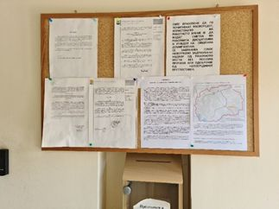 | Leaflet board  Gevgelija Municipality 1
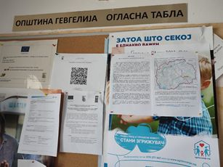 | Leaflet board  Gevgelija Municipality 2
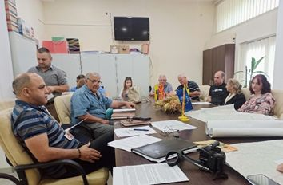 | Meeting  Municipality Demir Kapija

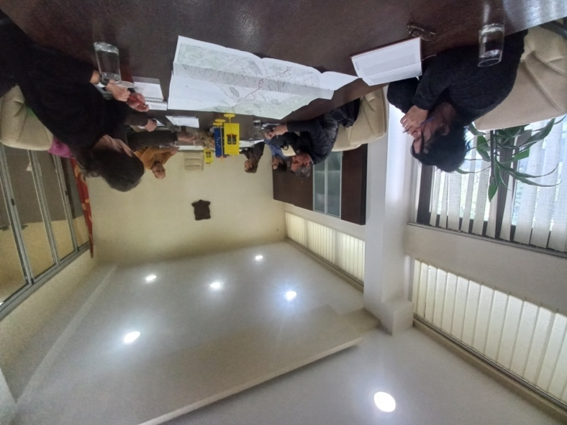 | Meeting  Municipality Demir Kapija
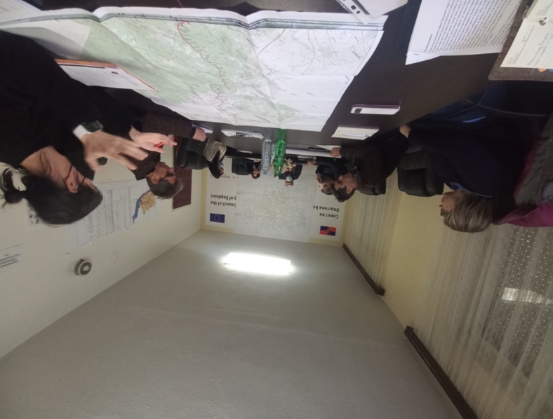 | Meeting  Municipality Bogdanci
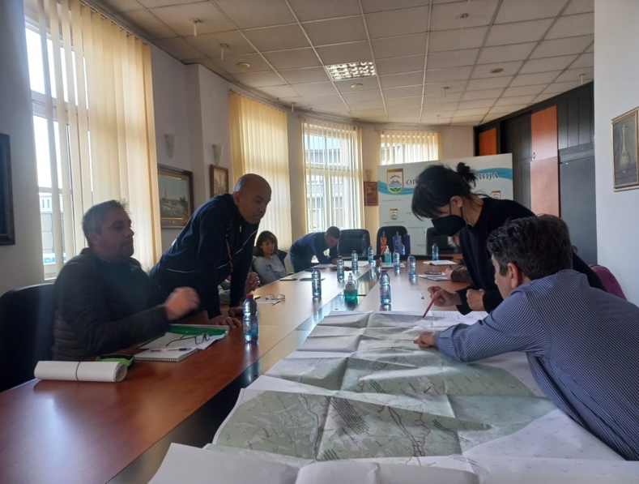 | Meeting  Municipality Gevgelija

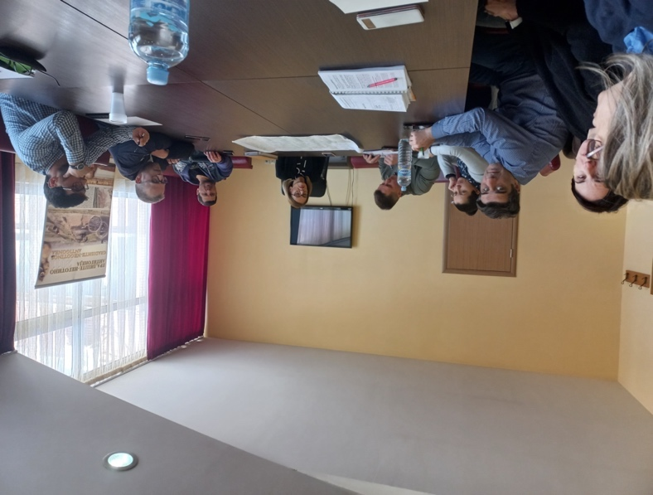 | Meeting  Municipality Negotino
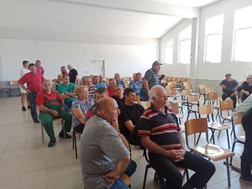 | Meeting  Negotsi village with land owners
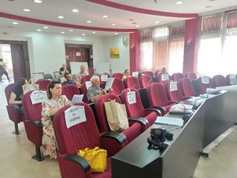 | Meeting  Municipality Negotino

Part B’: Participation Lists

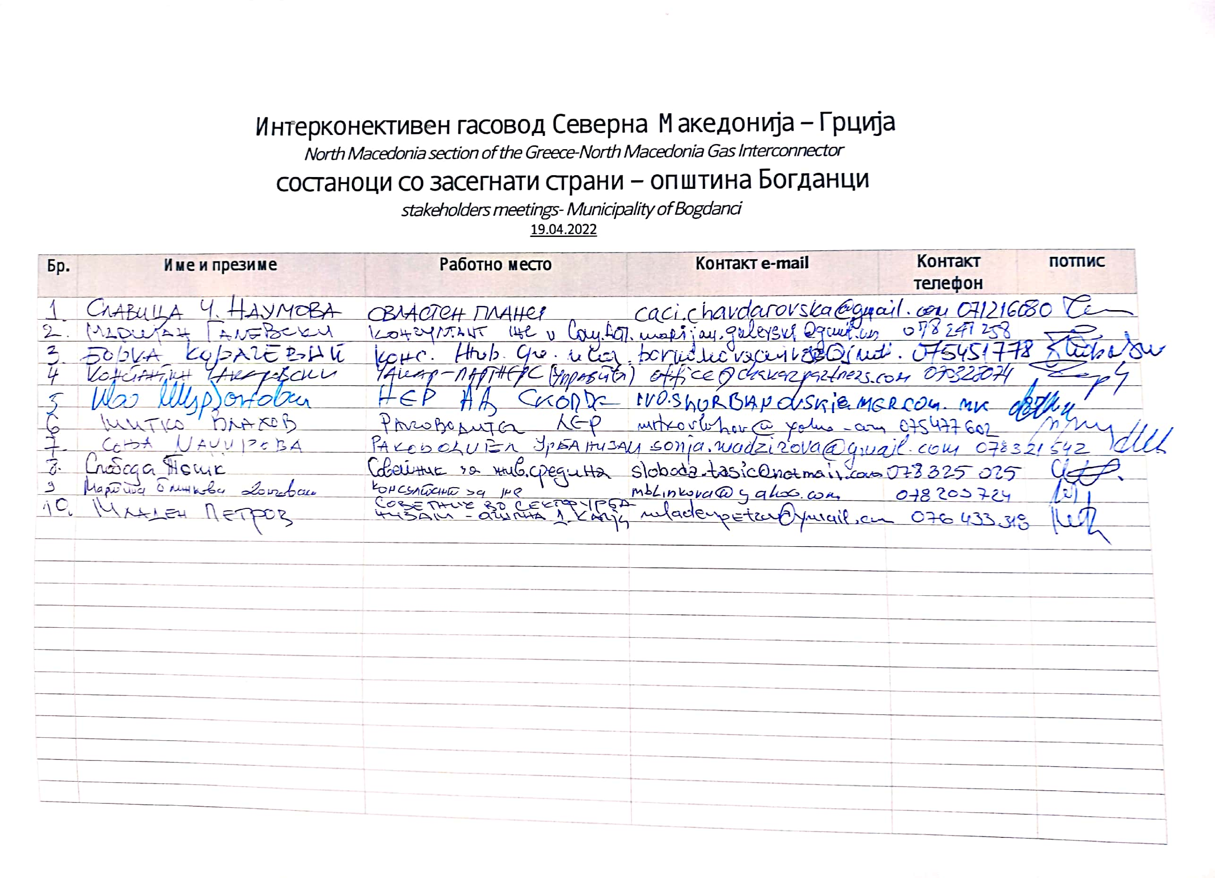
Bogdanci Municipality: Participant List

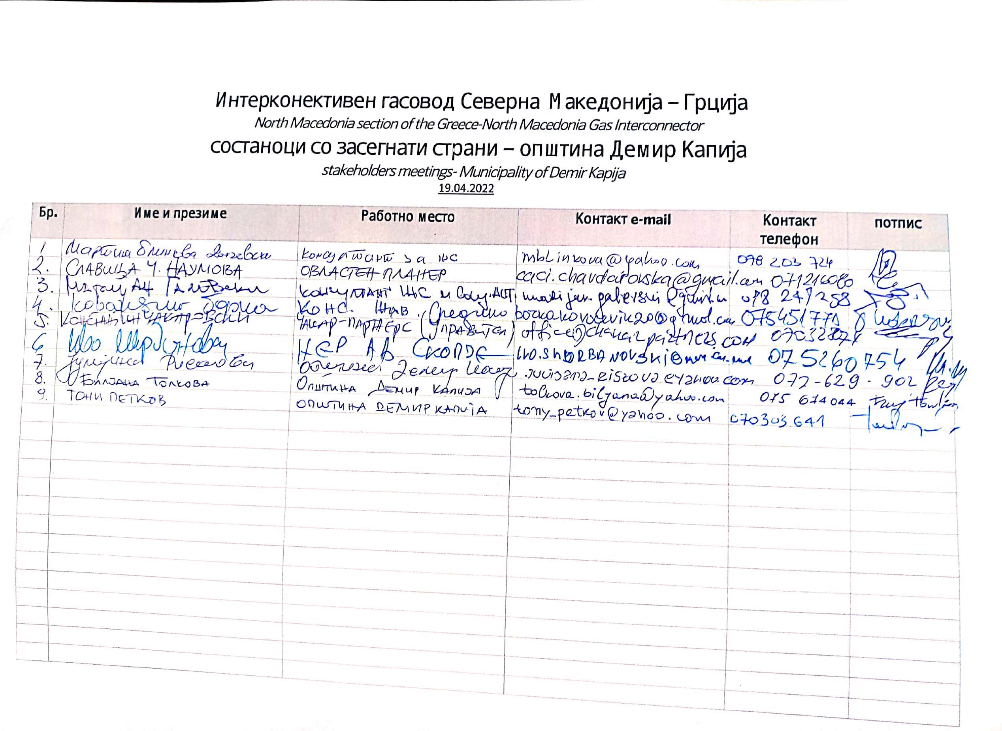
Municipality Demir Kapija: Participant List

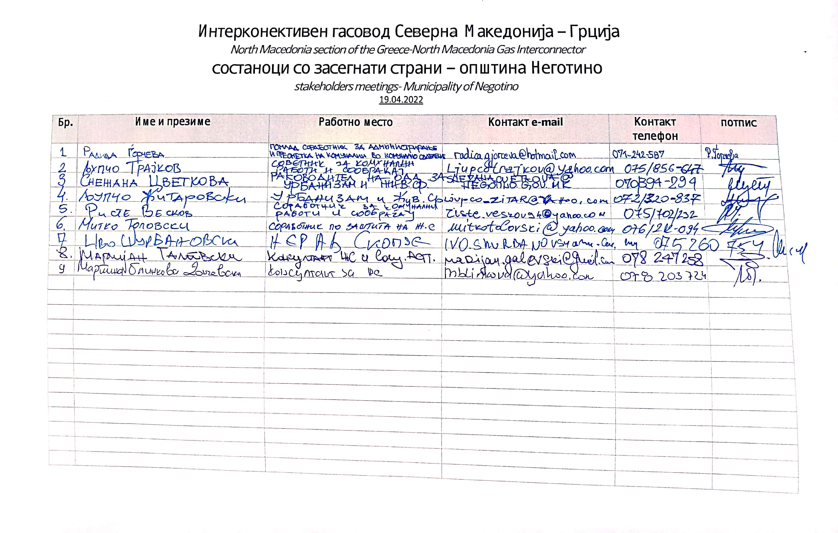
Municipality Negotino: Participant List

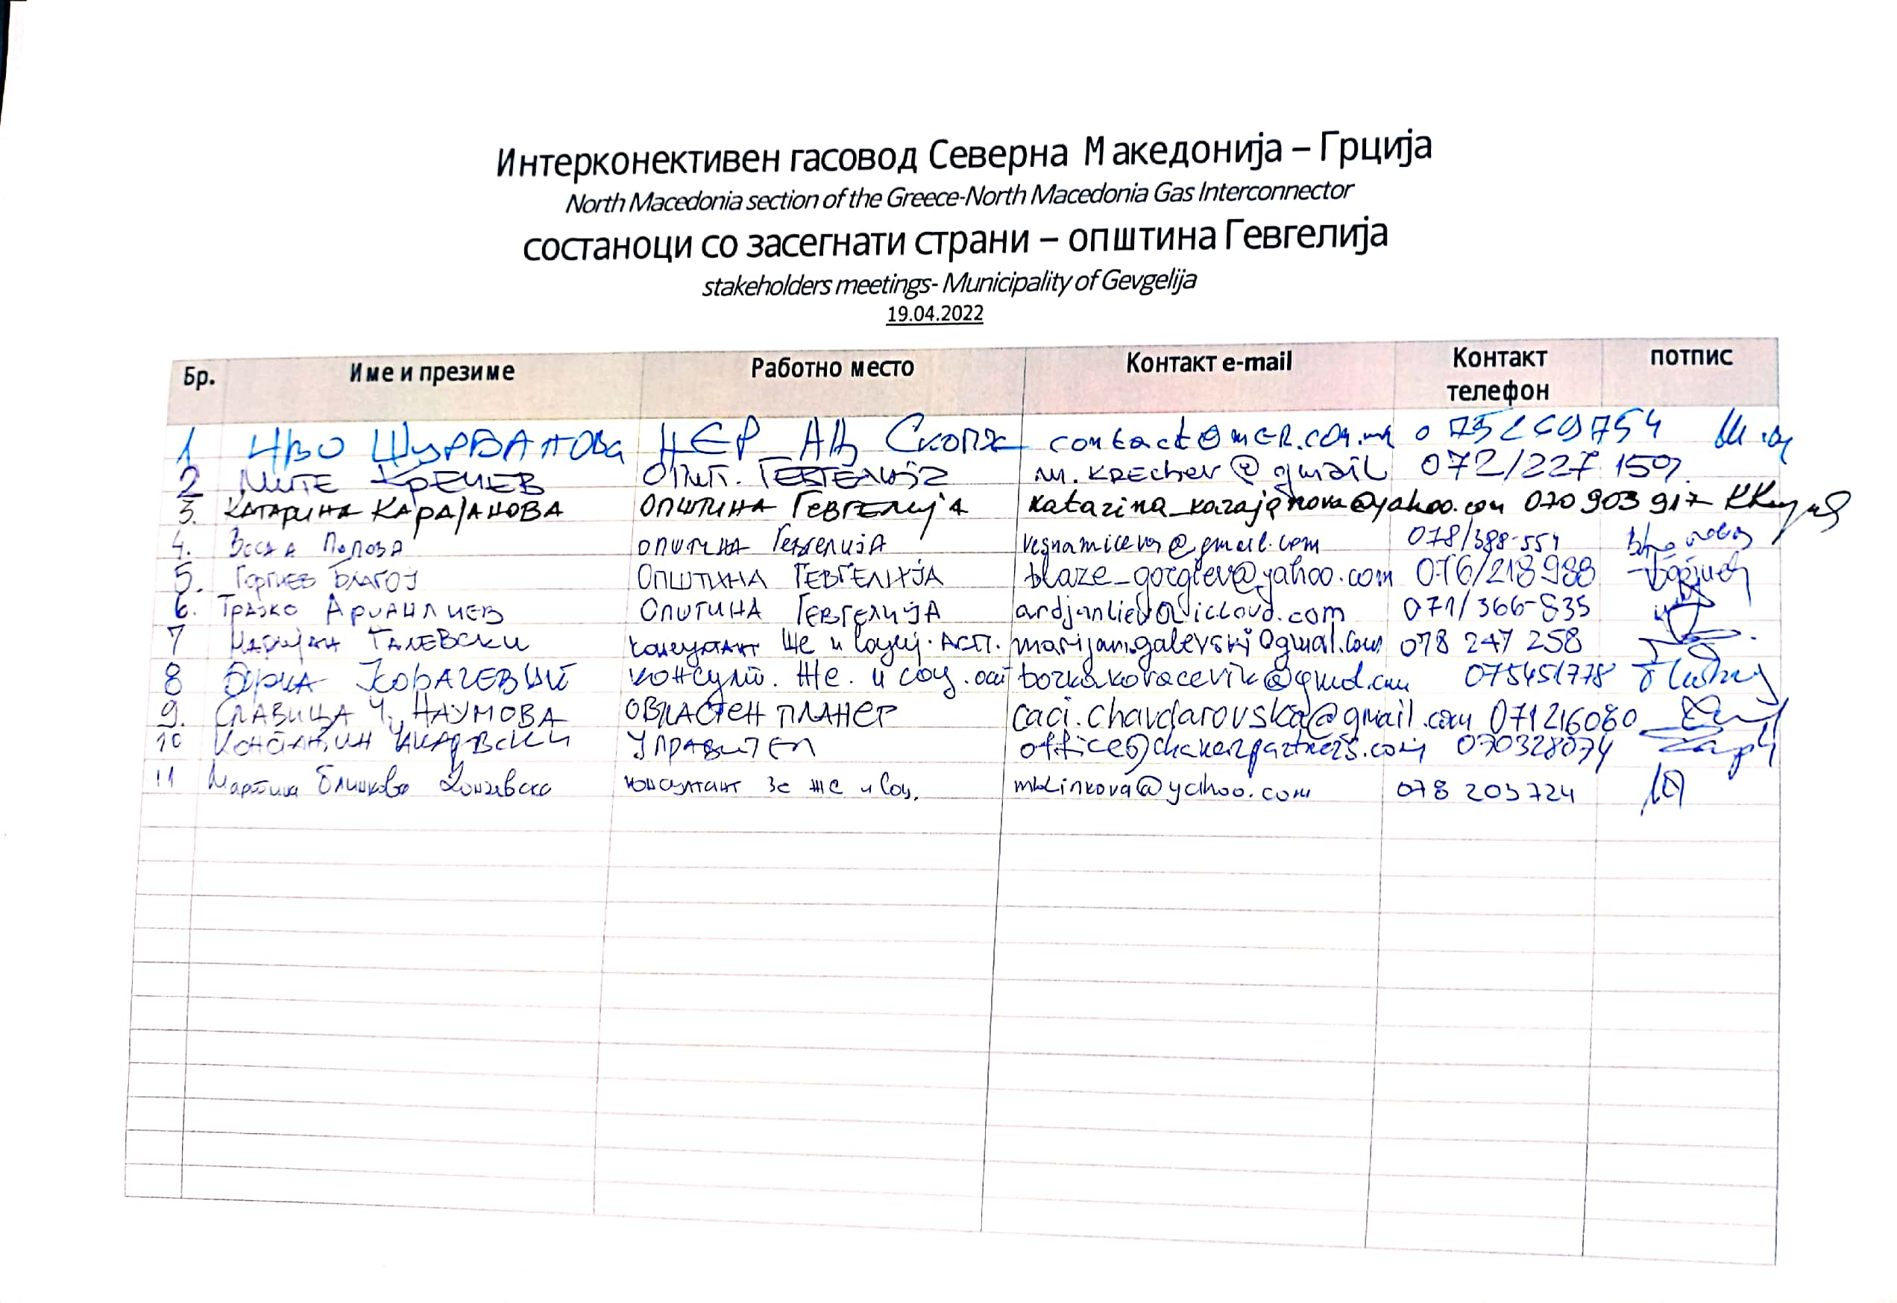
Municipality Gevgelija: Participant List

Part C’: Leaflets

Leaflet 1: Information about the Project “Interconnector North Macedonia – Greece”
This gas pipeline section is part of the National Gasification System in the Republic of North Macedonia. The Greece Interconnector North Macedonia project will ensure the security of the gas supply, both in the Republic of North Macedonia and in the region. This section ensures the connection of the existing trunk network in RNM with the gas pipeline network in Greece.
The starting point of the route in North Macedonia is the border with Greece near the village of Idomeni and the town of Gevgelija, where the Greek part of the pipeline ends. The final point is the already built block station (block station BS 7) of the new gas pipeline Shtip - Negotino, near the town of Negotino. The length of the gas pipeline route is 67 km and has a diameter of F700.
The investor of the Project is NER AD Skopje - National Energy Resources, a joint-stock company for performing energy activities, Skopje, in state ownership.
Importance of the project:
- Supporting the gasification of the country by providing an interconnection point that can supply large quantities of gas to meet the expected growth in demand,
- Ensures security of supply by offering diversification of supply sources,
- Ensures market integration in order to enable consumers in North Macedonia to have gas prices similar to those of neighboring countries,
- A sustainable source of energy for the country that has a low emission intensity index.
In accordance with the legal regulations of the RNM, appropriate technical documentation and a procedure for the Environmental Impact Assessment (EIA) have been developed in order to determine compliance with the standards for the environment and social aspects, i.e. to ensure that the project includes all necessary measures for the protection of the environment environment and social aspects as a basic condition for obtaining consent for its realization. In addition to the applied national legal requirements, the Environmental and Social Aspects Policies of the European Bank for Reconstruction and Development (EBRD) and the European Investment Bank have also been applied.
An Elaborate on permanent and temporary expropriation was prepared, which determined the need for access to land in the municipalities of Gevgelija, Bogdanci, Demir Kapija and Negotino, i.e. the corresponding cadastral municipalities, CM Negotino, CM Timjanik, CM Dubrovo, CM Tremnik, CM Przhdevo, CM Chiflik, CM Dren, CM Demir Kapija, CM Petrovo, CM Miravci outside the city, CM Gabrovo, CM Smokvitsa, CM Prdejtsi,CM Negorci, CM Stojakovo, CM Gjavato, CM Bogdanci outside the city and CM Bogorodica.

A Plan for the involvement of stakeholders and the community and public consultation during the assessment of environmental and social aspects and the development of technical documentation in accordance with national legislation and the requirements of the EBRD has also been developed.
The general layout of the project is presented in the following picture:
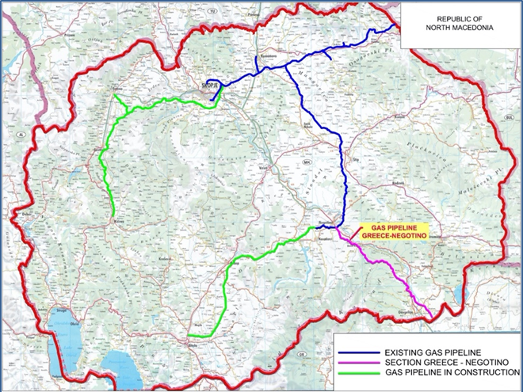
As part of the stakeholder involvement process, residents have the opportunity to submit questions or concerns through appropriate communication and a form that will be published on the website of the institution responsible for the project, National Energy Resources (NER JSC Skopje) or in the municipalities in the Project area. .

The questions can be submitted in written form and the form will be available in the municipal administration of the municipalities through which the gas pipeline passes. In addition to a written form, questions can also be submitted by contacting the Responsible Engineers for the project by phone or in person.

The contacts with National Energy Resources (NER AD Skopje) are as follows:
1. Ivo Surnanovski : ivo.shurbanovski@mer.com.mk; mob.: +389 75 269 754
2. Aleksandra Apostoloski aleksandar.apostoloski@mer.com.mk , mob.: +389 75 269 763

Leaflet 2: Information about the Project and Grievance Mechanism – Interconnector North Macedonia – Greece
This gas pipeline section is part of the National Gasification System in the Republic of North Macedonia. The Greece Interconnector North Macedonia project will ensure the security of the gas supply, both in the Republic of North Macedonia and in the region. This section ensures the connection of the existing trunk network in RNM with the gas pipeline network in Greece.
The starting point of the route in North Macedonia is the border with Greece near the village of Idomeni and the town of Gevgelija, where the Greek part of the pipeline ends. The final point is the already built block station (block station BS 7) of the new gas pipeline Shtip - Negotino, near the town of Negotino. The length of the gas pipeline route is 67 km and has a diameter of F700.
The investor of the Project is NER AD Skopje - National Energy Resources, a joint-stock company for performing energy activities, Skopje, in state ownership. The purpose of the grievance mechanism is to ensure that all requests and complaints from individuals, groups and local communities throughout the Project life are dealt with systematically in a timely manner with appropriate corrective actions being implemented and the complainant being informed of the outcome.
The investor of the Project is NER AD Skopje - National Energy Resources, a joint-stock company for performing energy activities, Skopje, in state ownership.
The general layout of the project is presented in the following picture:

NER established channels for grievance and information to enable stakeholders to register a concern or complaint about the Project or NER’s activities. Anonymous submissions will be accepted. The following channels shall be used to submit a grievance:
- NER’s (updated) website using an online form (the link will be included);
- In written form by post, fax or e-mail to a NER representative, a representative of the construction contractor, or a representative of a municipality;
- Verbally, through a dedicated phone line, or in person to a NER representative, a representative of the construction contractor, or a representative of a municipality.
All complaints will be logged and processed and addressed within a fixed time which shall be communicated to the complainant. The maximum duration of the grievance resolution process will not exceed 30 days.
Alternative dispute resolution options include negotiation and mediation to reach a consensual agreement. It also includes arbitration which lead to a non-binding recommendation or a decision and binding settlement.
The structure of the Grievance Sample Form is presented and will be available also online on the NER website.

Grievance formular:
First name
Last name
Gender: | Female  Male
Contact Information  Please mark how you wish to be contacted (mail, telephone, e-mail). | By E-mail: _______________________________________________  By Post: ________________________________________________  By Telephone: _______________________________________________
Preferred Language for communication | Macedonian  Albanian
Property Number and Cadastral Municipality (if impacted by land acquisition)
Confidentiality:
I request not to disclose my identity without my consent
I wish to raise my grievance anonymously*
*In case of anonymous grievances, we cannot communicate the response to you, but will publish the case and the response in the annual grievance report and on our website.
Description of Incident or Grievance:
What happened? Where did it happen? To whom did it happen? What is the result of the problem?
Date of Incident/Grievance
One time incident/grievance (date _______________)
Happened more than once (how many times? _____)
On-going (currently experiencing problem)
Additional supporting documentation: |  | Space to upload materials
What would you like to see happen to resolve the problem?
Signature of the complaint and date of submission:

Part D’: Minutes from Stakeholder Meetings

Meeting in Bogdanci Municipality
Preparation of supplementary Environmental and Social Impact Assessment Gas interconnector North Macedonia - Greece
Date: 19.04.2022
Time: 10:30 ‐12:00
Venue: Municipality of Bogdanci, Municipality Building, Mayor meeting hall
AGENDA
- Welcome and Introduction
- Introduction to the Project’s Scope and Main Goals (NER JSC Representative)
- Presentation of the Project and stakeholder engagement process , (Konstantin Cakarovski, design team leader and Borka Kovacevik social specialist , ESIA team member , Mott Macdonald)
- Discussion with Stakeholders

PARTICIPANTS
Please see attached the original participants list.
The meeting was opened by representative of National Energy Resources Skopje JSC, Ivo Surbanovski, who presented all the participants and shortly introduced the project, the aims, the scope and the current status of the project development. It was clarified that the Project is in accordance with national legislation and as well with EBRD and EIB requirements. The importance and aim of the Project is secure the gas supply, developing additional other gas supply routes, diversify energy sources, switch to cleaner energy sources and develop gas transmission networks to improve the integration of the country’s energy infrastructure.
Since the Project is supported by EBRD and EIB stakeholder engagement is very important part of the project development, an in timely manner inform affected PAPs related issues about ESIA, design, future land acquisition process etc. Also was discussed that affected communities and citizens will be continuously as previous period informed and municipality’s support is beneficial within this process of SE, so the leaflets and information should be disclosed on the municipality’s web sites and the Information Boards within the region of the Municipality.
Municipality was informed that further step as obligation for NER JSC would be SE with landowners, users in villages and towns along the route, informing generally about project, ESIA status and land acquisition.
Also information about grievance mechanism for PAP was discussed and that the purpose is to ensure that all requests and complaints from individuals, groups and local communities throughout the Project life will be dealt systematically in a timely manner with appropriate corrective actions being implemented and the complainant being informed of the outcome.
The maps and design data were shared and presented as well as the leaflets with information about project and grievance mechanism were shared within Municipality departments representatives and participants of the meeting (Local development department, Urban planning department, and Mayor cabinet etc).
Participants from the Municipality administration expressed gratitude for the shared information about the project. They informed that are familiar and consulted about the Project from the beginning in 2019 till now within the process of planning and designing the gas pipeline. Opinions have been submitted to the Planners and joint solutions have been adopted with the aim of reducing and avoiding especially social impacts on land acquisition, cultural heritage, protection of environment, while taking in considering urban plans as well as cumulative impacts with other projects that are planned or developed in the municipality.
Issues discussed:
- Time frame of development, (the answer from designers was that the plan for preparation and start of the construction is spring 2023)
- Possibility of connection in the future through a distribution network with the main gas pipeline (answer was that also that project for distribution network is under development under the management of NER JSC, but still the timing is unclear)
- Construction period (Answer, tender documentation is under preparation and will define the period)
- Support for meetings with PAPs in Stojakovo
Also, they confirmed that they are interested in SE process and will support communication with citizens in a timely manner for the sake of community safety and usage of existing infrastructure to access the area of the project during preparations and construction.

Meeting in Gevgelija Municipality

Preparation of supplementary Environmental and Social Impact Assessment Gas interconnector North Macedonia - Greece

Date: 19.04.2022
Time: 08:30 ‐10:00
Venue: Municipality of Gevgelija, Municipality Bulding (large meeting hall)

AGENDA
- Welcome and Introduction
- Introduction to the Project’s Scope and Main Goals (NER JSC Representative)
- Presentation of the Project and stakeholder engagement process , (Konstantin Cakarovski, design team leader and Borka Kovacevik social specialist , ESIA team member , Mott Macdonald)
- Discussion with Stakeholders

PARTICIPANTS
Please see attached the original participants list.

The meeting was opened by representative of National Energy Resources Skopje JSC, Ivo Surbanovski, who presented all the participants and shortly introduced the project, the aims, the scope and the current status of the project development. It was clarified that the Project is in accordance with national legislation and as well with EBRD and EIB requirements. The importance and aim of the Project is secure the gas supply, developing additional other gas supply routes, diversify energy sources, switch to cleaner energy sources and develop gas transmission networks to improve the integration of the country’s energy infrastructure.
Since the Project is supported by EBRD and EIB stakeholder engagement is very important part of the project development, an in timely manner inform affected PAPs related issues about ESIA, design, future land acquisition process etc. Also was discussed that affected communities and citizens will be continuously as previous period informed and municipality’s support is abeneficial within this process of SE, so the leaflets and information should be disclosed on the municipality’s web sites and the Information Boards within the region of the Municiplaity.
Municipality was informed that further step as obligation for NER JSC would be SE with landowners, users in villages and towns along the route, informing generally about project, ESIA status and land acquisition.
Also information about grievance mechanism for PAP was discussed and that the purpose is to ensure that all requests and complaints from individuals, groups and local communities throughout the Project life will be dealt systematically in a timely manner with appropriate corrective actions being implemented and the complainant being informed of the outcome.
The maps and design data were shared and presented as well as the leaflets with information about project and grievance mechanism were shared within Municipality departments representatives and participants of the meeting (Local development department, Urban planning department, and Mayor cabinet etc).
Participants from the Municipality administration expressed gratitude for the shared information about the project. They informed that are familiar and consulted about the Project from the beginning in 2019 till now within the process of planning and designing the gas pipeline. Opinions have been submitted to the Planners and joint solutions have been adopted with the aim of reducing and avoiding especially social impacts on land acquisition, cultural heritage, protection of environment, while taking in considering urban plans as well as cumulative impacts with other projects that are planned or developed in the municipality.
Issues discussed:
- Time frame of development, (the answer from designers was that the plan for preparation and start of the construction is spring 2023)
- Possibility of connection in the future through a distribution network with the main gas pipeline (answer was that also that project for distribution network is under development under the management of NER JSC, but still the timing is unclear)
- Construction period (Answer, tender documentation is under preparation and will define the period)
- Support for organizing meetings in villages: Gabrovo, ,Mrzentsi, Negortsi, Prdejtsi, Smokvitsa
Also, they confirmed that they are interested in SE process and will support communication with citizens in a timely manner for the sake of community safety and usage of existing infrastructure to access the area of the project during preparations and construction.

Meeting in Negotino Municipality

Preparation of supplementary Environmental and Social Impact Assessment Gas interconnector North Macedonia - Greece
Date: 19.04.2022
Time: 14:30 ‐16:00
Venue: Municipality of Negotino, Municipality Bulding, Main meeting hall

AGENDA
- Welcome and Introduction
- Introduction to the Project’s Scope and Main Goals (NER JSC Representative)
- Presentation of the Project and stakeholder engagement process , (Konstantin Cakarovski, design team leader and Borka Kovacevik social specialist , ESIA team member , Mott Macdonald)
- Discussion with Stakeholders

PARTICIPANTS
Please see attached the original participants list.

The meeting was opened by representative of National Energy Resources Skopje JSC, Ivo Surbanovski, who presented all the participants and shortly introduced the project, the aims, the scope and the current status of the project development. It was clarified that the Project is in accordance with national legislation and as well with EBRD and EIB requirements. The importance and aim of the Project are secure the gas supply, developing additional other gas supply routes, diversify energy sources, switch to cleaner energy sources and develop gas transmission networks to improve the integration of the country’s energy infrastructure.
Since the Project is supported by EBRD and EIB stakeholder engagement is very important part of the project development, an in timely manner inform affected PAPs related issues about ESIA, design, future land acquisition process etc. Also was discussed that affected communities and citizens will be continuously as previous period informed and municipality’s support is abeneficial within this process of SE, so the leaflets and information should be disclosed on the municipality’s web sites and the Information Boards within the region of the Municiplaity.
Municipality was informed that further step as obligation for NER JSC would be SE with landowners, users in villages and towns along the route, informing generally about project, ESIA status and land acquisition.
Also information about grievance mechanism for PAP was discussed and that the purpose is to ensure that all requests and complaints from individuals, groups and local communities throughout the Project life will be dealt systematically in a timely manner with appropriate corrective actions being implemented and the complainant being informed of the outcome.
The maps and design data were shared and presented as well as the leaflets with information about project and grievance mechanism were shared within Municipality departments representatives and participants of the meeting (Local development department, Urban planning department, and Mayor cabinet etc).
Participants from the Municipality administration expressed gratitude for the shared information about the project. They informed that are familiar and consulted about the Project from the beginning in 2019 till now within the process of planning and designing the gas pipeline. Opinions have been submitted to the Planners and joint solutions have been adopted with the aim of reducing and avoiding especially social impacts on land acquisition, cultural heritage, protection of environment, while taking in considering urban plans as well as cumulative impacts with other projects that are planned or developed in the municipality.
Issues discussed:
- Time frame of development, (Answer from designers was that the plan for preparation and start of the construction is spring 2023)
- Possibility of connection in the future through a distribution network with the main gas pipeline (Answer was that also that project for distribution network is under development under the management of NER JSC, but still the timing is unclear)
- Construction period (Answer: tender documentation is under preparation and will define the period)
Also, they confirmed that they are interested in SE process and will support communication with citizens in a timely manner for the sake of community safety and usage of existing infrastructure to access the area of the project during preparations and construction.

Meeting in Demir Kapija town, Demir Kapija Municipality

Preparation of supplementary Environmental and Social Impact Assessment Gas interconnector North Macedonia - Greece
Date: 11.05.2022
Time: 10:00 ‐12:00
Venue: Demir Kapija Municipal building, Mayor meeting hall
Participants: 23 citizens (landowners from town and villages), both women and men
AGENDA
- Welcome and Introduction to the Project’s Scope and Main Goals (NER JSC Representative)
- Presentation of the Project and stakeholder engagement process Borka Kovacevik social specialist, ESIA team member, Mott Macdonald)
- Discussion with Stakeholders
The meeting was opened by representative of National Energy Resources Skopje JSC, IAleksandar Apostoloski, who shortly introduced the project, the aims, the scope and the current status of the project development. It was clarified that the Project is in accordance with national legislation and as well with EBRD and EIB requirements. The importance and aim of the Project is secure the gas supply, developing additional other gas supply routes, diversify energy sources, switch to cleaner energy sources and develop gas transmission networks to improve the integration of the country’s energy infrastructure.
Since the Project is supported by EBRD and EIB stakeholder engagement is very important part of the project development, an in timely manner to inform affected PAPs related issues about ESIA, design, future land acquisition process etc. Also was discussed that affected communities and citizens will be continuously as previous period, and can also obtain information in the municipality, as well from municipality’s web sites. the municipalities and NER disclosed the information about the project with summary including technical information, developer, project contact persons for further questions, comments on their bulletin boards and web sites and contact information of the responsible personell from NER JSC.
On the meeting were present landowners from the village both women and man, as well representative of Roma population. General information about the project, ESIA status and land acquisition were shared.
Also, information about grievance mechanism for PAP was discussed and that the purpose is to ensure that all requests and complaints from individuals, groups in local communities throughout the Project life will be dealt systematically in a timely manner with appropriate corrective actions being implemented and the complainant being informed of the outcome.
The maps and design data were shared and presented as well as the leaflets with information about project and grievance mechanism.
Issues and questions discussed:
- Time frame of development and when will the construction start (Answer: NER JSC representative clarifies that the plan for preparation and start of the construction is spring 2023);
- Construction period (Answer: tender documentation is under preparation and will define the period);
- Process of land acquisition and level of compensation (Answer: process will be the transparent, according national legislation and EBRD requirements and SE engagement will support people to obtain in time all information and will have opportunity for comments or apply grievance mechanism);
- Construction methodology and the characteristics of the pipeline and the route in the locality, including location of BSs (Answer: Technical parameters data shared and explained with the map);
- Usage of access roads and possible damages (Answer: as less as possible will be made new access road, and existing ones including those for oil pipeline will be used for access to construction sites, in case of damage the contractor is obliged to repair and improve the infrastructure);
- Temporarily and permanently purchased land and in time information and engagement (Answer: technical parameters for required land shared);
- Concerns: whether the valuation process will be transparent and the funds paid will be fair and according to the market value of the land, (Answer: process will be transparent, according national legislation and EBRD requirements, and SE engagement will support people to obtain in time all information and will have opportunity for comments or apply grievance mechanism).
- How they will be engaged during construction in order the level of impacts to soil and crops on their land plots to be minimized? (Answer: Yes, they will be informed in time, NER has aexpirinece from construction of other main gas pipelines and support and understand their concern, so the mitigation measures will be applied)
- An additional comment was related to damage to the vineyards and how to protect them in order to continue the viticulture activity. Answer NER explained that they have previous experience in building gas pipelines in the area of vineyards and protection measures are applied which will be monitored and implemented by the Contractor and the Supervisor

Meeting with Gabrovo villagers, Gevgelija Municipality
Preparation of supplementary Environmental and Social Impact Assessment Gas Interconnector North Macedonia - Greece
Date: 18.05.2022
Time: 11:00 ‐13:00
Venue: Cultural home, town Gevgelija
Participants: 15 villagers (landowners), both women and men

AGENDA
- Welcome and Introduction to the Project’s Scope and Main Goals (NER JSC Representative)
- Presentation of the Project and stakeholder engagement process Borka Kovacevik social specialist, ESIA team member, Mott Macdonald)
- Discussion with Stakeholders
The meeting was opened by representative of National Energy Resources Skopje JSC, IAleksandar Apostoloski, who shortly introduced the project, the aims, the scope and the current status of the project development. It was clarified that the Project is in accordance with national legislation and as well with EBRD and EIB requirements. The importance and aim of the Project are secure the gas supply, developing additional other gas supply routes, diversify energy sources, switch to cleaner energy sources and develop gas transmission networks to improve the integration of the country’s energy infrastructure.
Since the Project is supported by EBRD and EIB stakeholder engagement is very important part of the project development, an in timely manner to inform affected PAPs related issues about ESIA, design, future land acquisition process etc. Also was discussed that affected communities and citizens will be continuously as previous period, and can also obtain information in the municipality, as well from municipality’s web sites. the municipalities and NER disclosed the information about the project with summary including technical information, developer, project contact persons for further questions, comments on their bulletin boards and web sites and contact information of the responsible personell from NER JSC.
On the meeting were present landowners from the village both women and man, as well representative of Roma population. General information about the project, ESIA status and land acquisition were shared.
Also information about grievance mechanism for PAP was discussed and that the purpose is to ensure that all requests and complaints from individuals, groups in local communities throughout the Project life will be dealt systematically in a timely manner with appropriate corrective actions being implemented and the complainant being informed of the outcome.
The maps and design data were shared and presented as well as the leaflets with information about project and grievance mechanism.
Issues and questions discussed:
- Time frame of development and when will the construction start (Answer: NER JSC representative clarifies that the plan for preparation and start of the construction is spring 2023);
- Construction period (Answer: tender documentation is under preparation and will define the period);
- Process of land acquisition and level of compensation (Answer: process will be the transparent, according national legislation and EBRD requirements and SE engagement will support people to obtain in time all information and will have opportunity for comments or apply grievance mechanism);
- Construction methodology and the characteristics of the pipeline and the route in the locality, including location of BSs (Answer: Technical parameters data shared and explained with the map);
- Usage of access roads and possible damages (Answer: as less as possible will be made new access road, and existing ones including those for oil pipeline will be used for access to construction sites, in case of damage the contractor is obliged to repair and improve the infrastructure);
- Temporarily and permanently purchased land and in time information and engagement (Answer: technical parameters for required land shared);
- Concerns: whether the valuation process will be transparent and the funds paid will be fair and according to the market value of the land, (Answer: process will be transparent, according national legislation and EBRD requirements, and SE engagement will support people to obtain in time all information and will have opportunity for comments or apply grievance mechanism).
- How they will be engaged during construction in order the level of impacts to soil and crops on their land plots to be minimized? (Ansewr: Yes, they will be informed in time, NER has aexpirinece from construction of other main gas pipelines and support and understand their concern, so the mitigation measures will be applied)

Meeting in Mrzentsi village, Gevgelija Municipality

Preparation of supplementary Environmental and Social Impact Assessment Gas Interconnector North Macedonia - Greece
Date: 04.05.2022
Time: 09:00 ‐10:45
Venue: Community building in village Mrzentsi
Participants: 30 villagers (landowners), both women and men, and disabled

AGENDA
- Welcome and Introduction to the Project’s Scope and Main Goals (NER JSC Representative)
- Presentation of the Project and stakeholder engagement process Borka Kovacevik social specialist, ESIA team member, Mott Macdonald)
- Discussion with Stakeholders
The meeting was opened by representative of National Energy Resources Skopje JSC, Aleksandar Apostoloski, who shortly introduced the project, the aims, the scope and the current status of the project development. It was clarified that the Project is in accordance with national legislation and as well with EBRD and EIB requirements. The importance and aim of the Project is secure the gas supply, developing additional other gas supply routes, diversify energy sources, switch to cleaner energy sources and develop gas transmission networks to improve the integration of the country’s energy infrastructure.
Since the Project is supported by EBRD and EIB stakeholder engagement is very important part of the project development, an in timely manner to inform affected PAPs related issues about ESIA, design, future land acquisition process etc. Also was discussed that affected communities and citizens will be continuously as previous period, and can also obtain information in the municipality, as well from municipality’s web sites. the municipalities and NER disclosed the information about the project with summary including technical information, developer, project contact persons for further questions, comments on their bulletin boards and web sites and contact information of the responsible personnel from NER JSC.
On the meeting were present landowners from the village both women and man, as well representative of Roma population. General information about the project, ESIA status and land acquisition were shared.
Also, information about grievance mechanism for PAP was discussed and that the purpose is to ensure that all requests and complaints from individuals, groups in local communities throughout the Project life will be dealt systematically in a timely manner with appropriate corrective actions being implemented and the complainant being informed of the outcome.
The maps and design data were shared and presented as well as the leaflets with information about project and grievance mechanism.
Issues and questions discussed:
- Time frame of development and when will the construction start (Answer: NER JSC representative clarifies that the plan for preparation and start of the construction is spring 2023);
- Construction period (Answer: tender documentation is under preparation and will define the period);
- Process of land acquisition and level of compensation (Answer: process will be the transparent, according national legislation and EBRD requirements and SE engagement will support people to obtain in time all information and will have opportunity for comments or apply grievance mechanism);
- Construction methodology and the characteristics of the pipeline and the route in the locality, including location of BSs (Answer: Technical parameters data shared and explained with the map);
- Usage of access roads and possible damages (Answer: as less as possible will be made new access road, and existing ones including those for oil pipeline will be used for access to construction sites, in case of damage the contractor is obliged to repair and improve the infrastructure);
- Temporarily and permanently purchased land and in time information and engagement (Answer: technical parameters for required land shared);
- Concerns: whether the valuation process will be transparent and the funds paid will be fair and according to the market value of the land, (Answer: process will be transparent, according national legislation and EBRD requirements, and SE engagement will support people to obtain in time all information and will have opportunity for comments or apply grievance mechanism).
- How they will be engaged during construction in order the level of impacts to soil and crops on their land plots to be minimized? (Ansewr: Yes, they will be informed in time, NER has experience from construction of other main gas pipelines and support and understand their concern, so the mitigation measures will be applied)
- Ann additional comment was related to the construction of the oil pipeline, where they were affected by improper reinstatement of RoW topsoil, humus layer mixed with other soil thus soil fertility was reduced that created problems for farmers (Answer: The Contractor and Supervision teams will be informed and will prevent this).

Meeting in Negortsi village, Gevgelija Municipality

Preparation of supplementary Environmental and Social Impact Assessment Gas Interconnector North Macedonia - Greece
Date: 04.05.2022
Time: 11:00 ‐13:00
Venue: Cultural home, village Negortsi
Participants: 75 villagers (landowners), both women and men, and disabled

AGENDA
- Welcome and Introduction to the Project’s Scope and Main Goals (NER JSC Representative)
- Presentation of the Project and stakeholder engagement process Borka Kovacevik social specialist, ESIA team member, Mott Macdonald)
- Discussion with Stakeholders
The meeting was opened by representative of National Energy Resources Skopje JSC, IAleksandar Apostoloski, who shortly introduced the project, the aims, the scope and the current status of the project development. It was clarified that the Project is in accordance with national legislation and as well with EBRD and EIB requirements. The importance and aim of the Project is secure the gas supply, developing additional other gas supply routes, diversify energy sources, switch to cleaner energy sources and develop gas transmission networks to improve the integration of the country’s energy infrastructure.
Since the Project is supported by EBRD and EIB stakeholder engagement is very important part of the project development, an in timely manner to inform affected PAPs related issues about ESIA, design, future land acquisition process etc. Also was discussed that affected communities and citizens will be continuously as previous period, and can also obtain information in the municipality, as well from municipality’s web sites. the municipalities and NER disclosed the information about the project with summary including technical information, developer, project contact persons for further questions, comments on their bulletin boards and web sites and contact information of the responsible personell from NER JSC.
On the meeting were present landowners from the village both women and man, as well representative of Roma population. General information about the project, ESIA status and land acquisition were shared.
Also, information about grievance mechanism for PAP was discussed and that the purpose is to ensure that all requests and complaints from individuals, groups in local communities throughout the Project life will be dealt systematically in a timely manner with appropriate corrective actions being implemented and the complainant being informed of the outcome.
The maps and design data were shared and presented as well as the leaflets with information about project and grievance mechanism.
Issues and questions discussed:
- Time frame of development and when will the construction start (Answer: NER JSC representative clarifies that the plan for preparation and start of the construction is spring 2023);
- Construction period (Answer: tender documentation is under preparation and will define the period);
- Process of land acquisition and level of compensation (Answer: process will be the transparent, according national legislation and EBRD requirements and SE engagement will support people to obtain in time all information and will have opportunity for comments or apply grievance mechanism);
- Construction methodology and the characteristics of the pipeline and the route in the locality, including location of BSs (Answer: Technical parameters data shared and explained with the map);
- Usage of access roads and possible damages (Answer: as less as possible will be made new access road, and existing ones including those for oil pipeline will be used for access to construction sites, in case of damage the contractor is obliged to repair and improve the infrastructure);
- Temporarily and permanently purchased land and in time information and engagement (Answer: technical parameters for required land shared);
- Concerns: whether the valuation process will be transparent and the funds paid will be fair and according to the market value of the land, (Answer: process will be transparent, according national legislation and EBRD requirements, and SE engagement will support people to obtain in time all information and will have opportunity for comments or apply grievance mechanism).
- How they will be engaged during construction in order the level of impacts to soil and crops on their land plots to be minimized? (Ansewr: Yes, they will be informed in time, NER has aexpirinece from construction of other main gas pipelines and support and understand their concern, so the mitigation measures will be applied)
- Ann additional comment was related to the construction of the oil pipeline, where they were affected by improper reinstatement of RoW topsoil, humus layer mixed with other soil thus soil fertility was reduced that created problems for farmers (Answer: The Contractor and Supervision teams will be informed and will prevent this).

Meeting in Negotino town, Negotino Municipality

Preparation of supplementary Environmental and Social Impact Assessment Gas Interconnector North Macedonia - Greece
Date: 11.05.2022
Time: 10:00 ‐12:00
Venue: Negotino Municipal building, main meeting hall
Participants: 17 citizens (landowners from town and villages), both women and men

AGENDA
- Welcome and Introduction to the Project’s Scope and Main Goals (NER JSC Representative)
- Presentation of the Project and stakeholder engagement process Borka Kovacevik social specialist, ESIA team member, Mott Macdonald)
- Discussion with Stakeholders
The meeting was opened by representative of National Energy Resources Skopje JSC, IAleksandar Apostoloski, who shortly introduced the project, the aims, the scope and the current status of the project development. It was clarified that the Project is in accordance with national legislation and as well with EBRD and EIB requirements. The importance and aim of the Project is secure the gas supply, developing additional other gas supply routes, diversify energy sources, switch to cleaner energy sources and develop gas transmission networks to improve the integration of the country’s energy infrastructure.
Since the Project is supported by EBRD and EIB stakeholder engagement is very important part of the project development, an in timely manner to inform affected PAPs related issues about ESIA, design, future land acquisition process etc. Also was discussed that affected communities and citizens will be continuously as previous period, and can also obtain information in the municipality, as well from municipality’s web sites. the municipalities and NER disclosed the information about the project with summary including technical information, developer, project contact persons for further questions, comments on their bulletin boards and web sites and contact information of the responsible personell from NER JSC.
On the meeting were present landowners from the village both women and man, as well representative of Roma population. General information about the project, ESIA status and land acquisition were shared.
Also, information about grievance mechanism for PAP was discussed and that the purpose is to ensure that all requests and complaints from individuals, groups in local communities throughout the Project life will be dealt systematically in a timely manner with appropriate corrective actions being implemented and the complainant being informed of the outcome.
The maps and design data were shared and presented as well as the leaflets with information about project and grievance mechanism.
Issues and questions discussed:
- Time frame of development and when will the construction start (Answer: NER JSC representative clarifies that the plan for preparation and start of the construction is spring 2023);
- Construction period (Answer: tender documentation is under preparation and will define the period);
- Process of land acquisition and level of compensation (Answer: process will be the transparent, according national legislation and EBRD requirements and SE engagement will support people to obtain in time all information and will have opportunity for comments or apply grievance mechanism);
- Construction methodology and the characteristics of the pipeline and the route in the locality, including location of BSs (Answer: Technical parameters data shared and explained with the map);
- Usage of access roads and possible damages (Answer: as less as possible will be made new access road, and existing ones including those for oil pipeline will be used for access to construction sites, in case of damage the contractor is obliged to repair and improve the infrastructure);
- Temporarily and permanently purchased land and in time information and engagement (Answer: technical parameters for required land shared);
- Concerns: whether the valuation process will be transparent and the funds paid will be fair and according to the market value of the land, (Answer: process will be transparent, according national legislation and EBRD requirements, and SE engagement will support people to obtain in time all information and will have opportunity for comments or apply grievance mechanism).
- How they will be engaged during construction in order the level of impacts to soil and crops on their land plots to be minimized? (Answer: Yes they will be informed in time, NER has aexpirinece from construction of other main gas pipelines and support and understand their concern, so the mitigation measures will be applied)
- An additional comment was related to damage to the vineyards and how to protect them in order to continue the viticulture activity. Answer NER explained that they have previous experience in building gas pipelines in the area of vineyards and protection measures are applied which will be monitored and implemented by the Contractor and the Supervisor

Meeting in Petrovo village, Gevgelija Municipality

Preparation of supplementary Environmental and Social Impact Assessment Gas Interconnector North Macedonia - Greece
Date: 04.05.2022
Time: 14:00 ‐15:30
Venue: Cultural home, village Petrovo,
Participants: 20 villagers (landowners), both women and men, disabled

AGENDA
- Welcome and Introduction to the Project’s Scope and Main Goals (NER JSC Representative)
- Presentation of the Project and stakeholder engagement process Borka Kovacevik social specialist, ESIA team member , Mott Macdonald)
- Discussion with Stakeholders
The meeting was opened by representative of National Energy Resources Skopje JSC, IAleksandar Apostoloski, who shortly introduced the project, the aims, the scope and the current status of the project development. It was clarified that the Project is in accordance with national legislation and as well with EBRD and EIB requirements. The importance and aim of the Project are secure the gas supply, developing additional other gas supply routes, diversify energy sources, switch to cleaner energy sources and develop gas transmission networks to improve the integration of the country’s energy infrastructure.
Since the Project is supported by EBRD and EIB stakeholder engagement is very important part of the project development, an in timely manner to inform affected PAPs related issues about ESIA, design, future land acquisition process etc. Also was discussed that affected communities and citizens will be continuously as previous period, and can also obtain information in the municipality, as well from municipality’s web sites. the municipalities and NER disclosed the information about the project with summary including technical information, developer, project contact persons for further questions, comments on their bulletin boards and web sites and contact information of the responsible personell from NER JSC.
On the meeting were present landowners from the village both women and man, as well representative of Roma population. General information about the project, ESIA status and land acquisition were shared.
Also, information about grievance mechanism for PAP was discussed and that the purpose is to ensure that all requests and complaints from individuals, groups in local communities throughout the Project life will be dealt systematically in a timely manner with appropriate corrective actions being implemented and the complainant being informed of the outcome.
The maps and design data were shared and presented as well as the leaflets with information about project and grievance mechanism.
Issues and questions discussed:
- Time frame of development and when will the construction start (Answer: NER JSC representative clarifies that the plan for preparation and start of the construction is spring 2023);
- Construction period (Answer: tender documentation is under preparation and will define the period);
- Process of land acquisition and level of compensation (Answer: process will be the transparent, according national legislation and EBRD requirements and SE engagement will support people to obtain in time all information and will have opportunity for comments or apply grievance mechanism);
- Construction methodology and the characteristics of the pipeline and the route in the locality, including location of BSs (Answer: Technical parameters data shared and explained with the map);
- Usage of access roads and possible damages (Answer: as less as possible will be made new access road, and existing ones including those for oil pipeline will be used for access to construction sites, in case of damage the contractor is obliged to repair and improve the infrastructure);
- Temporarily and permanently purchased land and in time information and engagement (Answer: technical parameters for required land shared);
- Concerns: whether the valuation process will be transparent and the funds paid will be fair and according to the market value of the land, (Answer: process will be transparent, according national legislation and EBRD requirements, and SE engagement will support people to obtain in time all information and will have opportunity for comments or apply grievance mechanism).
- How they will be engaged during construction in order the level of impacts to soil and crops on their land plots to be minimized? (Ansewr: Yes, they will be informed in time, NER has aexpirinece from construction of other main gas pipelines and support and understand their concern, so the mitigation measures will be applied)
- Ann additional comment was related to the construction of the oil pipeline, where they were affected by improper reinstatement of RoW topsoil, humus layer mixed with other soil thus soil fertility was reduced that created problems for farmers (Answer: The Contractor and Supervision teams will be informed and will prevent this).

Meeting in Prdejtsi village, Gevgelija Municipality

Preparation of supplementary Environmental and Social Impact Assessment Gas Interconnector North Macedonia - Greece
Date: 05.05.2022
Time: 13:00 ‐15:00
Venue: Community building in village Prdejtsi
Participants: 43 villagers (landowners), both women and men, and disabled

AGENDA
- Welcome and Introduction to the Project’s Scope and Main Goals (NER JSC Representative)
- Presentation of the Project and stakeholder engagement process Borka Kovacevik social specialist, ESIA team member, Mott Macdonald)
- Discussion with Stakeholders
The meeting was opened by representative of National Energy Resources Skopje JSC, IAleksandar Apostoloski, who shortly introduced the project, the aims, the scope and the current status of the project development. It was clarified that the Project is in accordance with national legislation and as well with EBRD and EIB requirements. The importance and aim of the Project are secure the gas supply, developing additional other gas supply routes, diversify energy sources, switch to cleaner energy sources and develop gas transmission networks to improve the integration of the country’s energy infrastructure.
Since the Project is supported by EBRD and EIB stakeholder engagement is very important part of the project development, an in timely manner to inform affected PAPs related issues about ESIA, design, future land acquisition process etc. Also was discussed that affected communities and citizens will be continuously as previous period, and can also obtain information in the municipality, as well from municipality’s web sites. the municipalities and NER disclosed the information about the project with summary including technical information, developer, project contact persons for further questions, comments on their bulletin boards and web sites and contact information of the responsible personell from NER JSC.
On the meeting were present landowners from the village both women and man, as well representative of Roma population. General information about the project, ESIA status and land acquisition were shared.
Also information about grievance mechanism for PAP was discussed and that the purpose is to ensure that all requests and complaints from individuals, groups in local communities throughout the Project life will be dealt systematically in a timely manner with appropriate corrective actions being implemented and the complainant being informed of the outcome.
The maps and design data were shared and presented as well as the leaflets with information about project and grievance mechanism.
Issues and questions discussed:
- Time frame of development and when will the construction start (Answer: NER JSC representative clarifies that the plan for preparation and start of the construction is spring 2023);
- Construction period (Answer: tender documentation is under preparation and will define the period);
- Process of land acquisition and level of compensation (Answer: process will be the transparent, according national legislation and EBRD requirements and SE engagement will support people to obtain in time all information and will have opportunity for comments or apply grievance mechanism);
- Construction methodology and the characteristics of the pipeline and the route in the locality, including location of BSs (Answer: Technical parameters data shared and explained with the map);
- Usage of access roads and possible damages (Answer: as less as possible will be made new access road, and existing ones including those for oil pipeline will be used for access to construction sites, in case of damage the contractor is obliged to repair and improve the infrastructure);
- Temporarily and permanently purchased land and in time information and engagement (Answer: technical parameters for required land shared);
- Concerns: whether the valuation process will be transparent and the funds paid will be fair and according to the market value of the land, (Answer: process will be transparent, according national legislation and EBRD requirements, and SE engagement will support people to obtain in time all information and will have opportunity for comments or apply grievance mechanism).
- How they will be engaged during construction in order the level of impacts to soil and crops on their land plots to be minimized? (Ansewr: Yes, they will be informed in time, NER has aexpirinece from construction of other main gas pipelines and support and understand their concern, so the mitigation measures will be applied)
- Ann additional comment was related to the construction of the oil pipeline, where they were affected by improper reinstatement of RoW topsoil, humus layer mixed with other soil thus soil fertility was reduced that created problems for farmers (Answer: The Contractor and Supervision teams will be informed and will prevent this).

Meeting in Stojakovo village, Bogdanci Municipality

Preparation of supplementary Environmental and Social Impact Assessment Gas Interconnector North Macedonia - Greece
Date: 05.05.2022
Time: 16:30 ‐18:00
Venue: Cultural home, village Stojakovo
Participants: 20 villagers (landowners), both women and men, disabled, and Roma representatives

AGENDA
- Welcome and Introduction to the Project’s Scope and Main Goals (NER JSC Representative)
- Presentation of the Project and stakeholder engagement process Borka Kovacevik social specialist, ESIA team member, Mott Macdonald)
- Discussion with Stakeholders
The meeting was opened by representative of National Energy Resources Skopje JSC, IAleksandar Apostoloski, who shortly introduced the project, the aims, the scope and the current status of the project development. It was clarified that the Project is in accordance with national legislation and as well with EBRD and EIB requirements. The importance and aim of the Project is secure the gas supply, developing additional other gas supply routes, diversify energy sources, switch to cleaner energy sources and develop gas transmission networks to improve the integration of the country’s energy infrastructure.
Since the Project is supported by EBRD and EIB stakeholder engagement is very important part of the project development, an in timely manner to inform affected PAPs related issues about ESIA, design, future land acquisition process etc. Also was discussed that affected communities and citizens will be continuously as previous period, and can also obtain information in the municipality, as well from municipality’s web sites. the municipalities and NER disclosed the information about the project with summary including technical information, developer, project contact persons for further questions, comments on their bulletin boards and web sites and contact information of the responsible personell from NER JSC.
On the meeting were present landowners from the village both women and man, as well representative of Roma population. General information about the project, ESIA status and land acquisition were shared.
Also, information about grievance mechanism for PAP was discussed and that the purpose is to ensure that all requests and complaints from individuals, groups in local communities throughout the Project life will be dealt systematically in a timely manner with appropriate corrective actions being implemented and the complainant being informed of the outcome.
The maps and design data were shared and presented as well as the leaflets with information about project and grievance mechanism.
Issues and questions discussed:
- Time frame of development and when will the construction start (Answer: NER JSC representative clarifies that the plan for preparation and start of the construction is spring 2023);
- Construction period (Answer: tender documentation is under preparation and will define the period);
- Process of land acquisition and level of compensation (Answer: process will be the transparent, according national legislation and EBRD requirements and SE engagement will support people to obtain in time all information and will have opportunity for comments or apply grievance mechanism);
- Construction methodology and the characteristics of the pipeline and the route in the locality, including location of BSs (Answer: Technical parameters data shared and explained with the map);
- Usage of access roads and possible damages (Answer: as less as possible will be made new access road, and existing ones including those for oil pipeline will be used for access to construction sites, in case of damage the contractor is obliged to repair and improve the infrastructure);
- Temporarily and permanently purchased land and in time information and engagement (Answer: technical parameters for required land shared);
- Concerns: whether the valuation process will be transparent and the funds paid will be fair and according to the market value of the land, (Answer: process will be transparent, according national legislation and EBRD requirements, and SE engagement will support people to obtain in time all information and will have opportunity for comments or apply grievance mechanism).
- How they will be engaged during construction in order the level of impacts to soil and crops on their land plots to be minimized? (Answer: Yes they will be informed in time, NER has aexpirinece from construction of other main gas pipelines and support and understand their concern, so the mitigation measures will be applied)

